

E-COMMERCE RECOMMENDATION ENGINE
A PROJECT REPORT
Submitted in partial fulfillment of the requirements for the award of the degree of

MASTER OF TECHNOLOGY
in
COMPUTER SCIENCE AND ENGINEERING

By
KONTHAM VIVEK
Student ID: 2601050035

Under the supervision of
Dr.Raju Anitha
Department of Computer Science and Engineering


Koneru Lakshmaiah Education Foundation (KLEF)
Vaddeswaram, Andhra Pradesh, India
2026

DECLARATION
I hereby declare that the project report entitled “E-commerce Recommendation Engine” is prepared for academic purposes and submitted in partial fulfillment of the requirements for the degree of Master of Technology in Computer Science and Engineering at Koneru Lakshmaiah Education Foundation. The report describes a conceptual and implementation-oriented recommendation system that uses product metadata and shopper interaction signals to rank potentially relevant products.
The report is based on the two supplied PDF documents. The provided materials do not include a reference CSV, source-code repository, an existing editable report, or verified experiment logs. Consequently, the implementation descriptions are framed as a proposed design, and all numerical charts and sample outputs are explicitly marked illustrative rather than measured project results. The literature citations cannot be completed from the requested CSV because that file was not supplied.
I understand that any final submission should be checked against the actual implementation, institutional requirements, and the references approved for this project.
Place: Vaddeswaram
Signature of the Student: KONTHAM VIVEK (2601050035)

ACKNOWLEDGEMENT
I express my sincere gratitude to Koneru Lakshmaiah Education Foundation and the Department of Computer Science and Engineering for the academic environment in which this project topic could be explored. I am thankful to the faculty members whose instruction in software engineering, data structures, databases, and machine learning provides the foundation for understanding recommendation systems.
I also acknowledge the supplied project overview PDF, which explains recommendation signals, content-based and collaborative approaches, and the value of product discovery, and the supplied final project report PDF, which provides a useful model for formal academic organization and technical documentation.
I extend my thanks to everyone who may provide guidance and feedback during implementation, testing, and evaluation. The report distinguishes proposed design choices from verified implementation results so that the final project can be updated transparently when source code and experimental evidence are available.

Signature of the Student: KONTHAM VIVEK (2601050035)
Place: Vaddeswaram

INDEX
S. No. | Chapter / Section | Page
1 | Abstract | 5
2 | Introduction and Problem Definition | 6–9
3 | Literature Survey and Theoretical Foundations | 10–13
4 | System Analysis and Requirements | 14–16
5 | System Design and Architecture | 17–22
6 | Methodology and Algorithms | 23–26
7 | Implementation and Module Descriptions | 27–29
8 | Experimental Results, Testing and Discussion | 30–33
9 | Conclusion, Limitations and Future Enhancements | 34–35
10 | References and Appendix | 36–38

LIST OF TABLES
Table | Title
4.1 | Functional requirements
4.2 | Non-functional requirements
4.3 | Feasibility analysis
5.1 | Architecture layers
5.2 | Data entities
6.1 | Recommendation methods comparison
6.2 | Evaluation metrics
7.1 | Proposed modules
8.1 | Illustrative test cases
8.2 | Performance-analysis template

LIST OF FIGURES
Figure | Caption
3.1 | Recommendation signal-to-output concept
3.2 | Conceptual product ranking example
5.1 | Proposed system architecture
5.2 | Recommendation workflow
5.3 | Use case diagram
5.4 | Sequence diagram
5.5 | Activity diagram
5.6 | Level-1 data flow diagram
5.7 | Conceptual entity-relationship diagram
8.1 | Illustrative normalized score comparison

ABSTRACT
Online retail platforms often present thousands of products, making it difficult for shoppers to locate items that match their interests. An e-commerce recommendation engine addresses this information-overload problem by using product information and user activity—such as product views, searches, cart additions, and purchases—to identify and rank potentially relevant products. The supplied project overview introduces two common approaches: content-based recommendation, which suggests products similar to those a shopper has viewed, and collaborative recommendation, which uses patterns across shoppers with similar behavior.
This report proposes a modular recommendation-engine design for an online store. The system collects interaction events, validates and transforms them into usable features, generates candidate products, assigns relevance scores, applies business and availability filters, ranks the candidates, and returns a short list to the storefront. A content-based baseline can use product categories, descriptions, and attributes; a collaborative component can estimate preferences from an interaction matrix when sufficient data exists. A hybrid strategy can combine both signals and use a popularity-based fallback for new or anonymous shoppers.
The report presents the problem definition, related concepts, requirements, architecture, workflow, algorithmic formulations, data model, implementation modules, testing plan, evaluation metrics, and future enhancements. It includes black-and-white system diagrams and a clearly labelled illustrative graph. Because the supplied files do not contain project source code, a reference CSV, or measured experiment logs, this report does not claim that the proposed engine has been implemented or that the illustrative scores represent actual performance. The document should be reconciled with the completed code and validated results before final submission.
Keywords: e-commerce, recommender systems, content-based filtering, collaborative filtering, hybrid recommendation, ranking, personalization, evaluation.

1 INTRODUCTION

1.1 Background
E-commerce has changed how customers discover, compare, and purchase products. A digital store can expose a catalogue containing thousands or millions of items, but a large catalogue does not automatically create a good shopping experience. Customers must still decide which items are relevant, affordable, compatible, and worth examining. Search and category navigation are essential, yet they require shoppers to know what they want or how to express it. A recommendation engine provides another route through the catalogue by placing potentially useful products in context.

1.2 Motivation
A useful recommendation reduces the effort required to explore a catalogue and can expose products that a shopper would not otherwise discover. The supplied overview describes a simple signal loop: the system notices products viewed, items added to a cart, and past purchases or searches; it then identifies patterns, ranks matches, and displays suggestions. These signals differ in strength. A purchase often expresses stronger intent than a brief view, while a cart addition may indicate consideration without a completed transaction. A practical engine should represent these differences rather than treating every event identically.
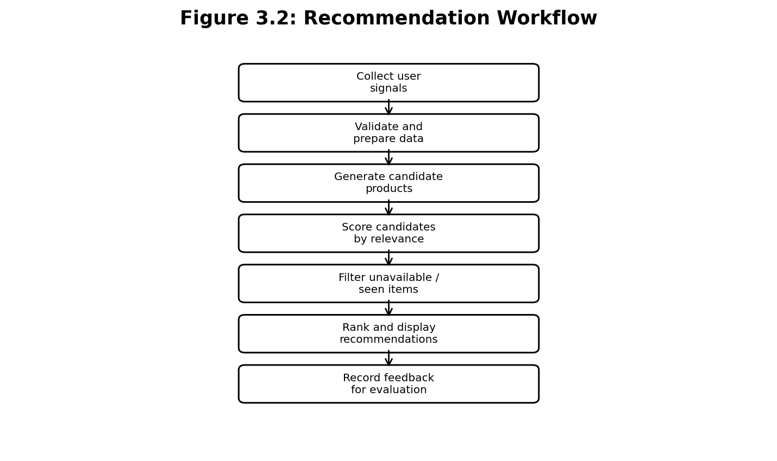
Figure 1.1: Conceptual flow from shopper signals to ranked recommendations.

1.3 Problem Definition
The project problem is to design a system that receives a product catalogue and available shopper-interaction events and returns a ranked list of eligible products for a given shopper or browsing context. Recommendations should be relevant, timely, explainable enough to inspect, and computationally practical. The system must handle sparse histories, new products, unavailable inventory, duplicate recommendations, and the cold-start case in which no personal history is available.

1.4 Objectives
The objectives are to define a modular recommendation architecture; model product metadata and interaction events; implement or specify candidate generation and ranking; compare content-based, collaborative, popularity-based, and hybrid approaches; define measurable offline and online evaluation methods; and provide a maintainable path for testing, monitoring, and future extension.

1.5 Scope
The proposed scope is a learning-oriented e-commerce recommendation service. It covers catalogue data, interaction processing, candidate generation, ranking, filtering, output presentation, and evaluation. It does not claim integration with a live commercial store, real payment infrastructure, production customer data, or a deployed machine-learning model. Such integrations require actual source code, credentials, data governance, and deployment evidence not present in the supplied materials.

1.6 Existing System
A basic online store commonly relies on keyword search, category browsing, manually curated lists, or globally popular products. These mechanisms are understandable and useful, but they may not adapt to differences between shoppers. A popularity list can repeatedly show the same high-volume items; keyword search can fail when shoppers cannot name the desired item; manual curation requires continuous editorial effort. Simple recommendations based only on the last viewed item may also overfit to a short-lived action.

1.7 Proposed System
The proposed engine combines product attributes with behavioral signals. It first obtains a valid catalogue and interaction history. It then builds product features and, when data permits, user-item preference signals. Candidate generators propose possible items, a ranking stage calculates a relevance score, and filters remove unavailable, disallowed, or redundant items. A fallback strategy returns popular or category-relevant products when personal history is insufficient. Feedback events are logged to support evaluation and iterative improvement.

1.8 Report Organization
Chapter 2 reviews the recommendation approaches represented in the supplied overview and explains their theoretical basis. Chapter 3 defines system requirements and feasibility. Chapter 4 describes architecture and diagrams. Chapter 5 explains the proposed methodology and algorithms. Chapter 6 outlines implementation modules. Chapter 7 defines experiments and testing, with all example values labelled illustrative. Chapter 8 discusses limitations and enhancements, followed by references and appendices.

2 LITERATURE SURVEY AND THEORETICAL FOUNDATIONS

2.1 Recommendation Systems
A recommender system estimates which items may be useful to a particular user or context. It can be viewed as a decision-support layer between a large catalogue and a shopper. Its output is generally a ranked list rather than a binary decision. The ranking is uncertain: a score is an estimate of relative relevance under a chosen model, not a guarantee that a customer will like or buy the item.

2.2 Content-Based Filtering
Content-based filtering represents each product through attributes such as title, category, brand, description, price range, and technical features. A user profile can be built from items the user has viewed, saved, or purchased. Candidate items are compared with this profile, often using cosine similarity over feature vectors. The method can recommend newly listed products when their metadata is available, but its quality depends on informative and accurate product descriptions. It may also narrow recommendations to items similar to a shopper's past behavior, reducing discovery of unfamiliar categories.

2.3 Collaborative Filtering
Collaborative filtering derives recommendations from interaction patterns across users and products. In user-based methods, shoppers with similar histories inform one another's recommendations. In item-based methods, products interacted with by similar groups can be recommended together. Matrix factorization and neighborhood methods are common conceptual families. Collaborative approaches can uncover relationships not obvious from product metadata, but sparse interaction matrices and new users or items make reliable estimates difficult.
Approach | Main evidence | Strength | Typical limitation
Content-based | Product attributes and a user profile | Can handle new items with metadata | May overspecialize
Collaborative | Patterns across users/items | Can reveal non-obvious relationships | Cold start and sparsity
Popularity baseline | Global or segment-level frequency | Simple and robust fallback | Limited personalization
Hybrid | Combination of multiple signals | Can balance coverage and relevance | Requires calibration and evaluation

2.4 Hybrid Recommendation
A hybrid system combines multiple recommendation signals. A weighted hybrid may calculate a score from content similarity, collaborative preference, popularity, and contextual relevance. A switching hybrid selects a method according to data availability—for example, content-based results for a new product and collaborative results for a shopper with sufficient history. Hybridization can improve coverage and resilience, but weights must be tuned and the resulting behavior must be evaluated rather than assumed to be superior.

2.5 Ranking and Candidate Generation
Candidate generation narrows a large catalogue to a manageable set of plausible items. Ranking then orders those candidates. Separating the stages supports scalability: inexpensive retrieval can identify a few hundred candidates, while more detailed scoring can operate on that smaller set. Eligibility filtering should be explicit and occur before final presentation so that unavailable products, items blocked by business rules, or products already purchased when inappropriate are not surfaced.

2.6 Feedback Signals
Views, clicks, cart additions, purchases, ratings, and search events are implicit or explicit feedback. Implicit signals are abundant but ambiguous: not clicking an item does not necessarily mean dislike, and a view can be accidental. The event model should preserve timestamps, session or user identifiers where permitted, product identifiers, event type, and relevant context. A scoring policy may assign different weights to events, but those weights are design parameters that require validation.

2.7 Research Gap and Project Positioning
The supplied overview is introductory and does not provide a bibliography, implementation details, or quantitative comparisons. It establishes the core distinction between content-based and collaborative approaches and describes the flow from signals to ranked suggestions. This project report expands that conceptual foundation into a software design with explicit data handling, fallback behavior, evaluation metrics, and testable requirements. It does not claim a novel recommendation algorithm or a completed empirical comparison.

2.8 Theoretical Foundations and Scoring
Let U denote users, I denote products, and R denote observed interactions. For a user u and item i, a hybrid score can be expressed as S(u,i)=αC(u,i)+βF(u,i)+γP(i)+δX(u,i), where C is content similarity, F is collaborative preference, P is normalized popularity, X represents contextual or business relevance, and α, β, γ, δ are non-negative weights. If all components are normalized to [0,1], weights may be constrained to sum to one for interpretability. When a component is unavailable, the engine should renormalize the remaining applicable weights or use a defined fallback.

2.9 Similarity Measures
For feature vectors x and y, cosine similarity is cos(x,y)=(x·y)/(||x|| ||y||), provided both vectors have non-zero norm. It measures orientation rather than magnitude and is often useful for sparse text or categorical feature vectors. For binary interaction vectors, Jaccard similarity can be used: J(A,B)=|A∩B|/|A∪B| when the union is non-empty. The selected measure must match the representation and should be tested on edge cases such as empty profiles.

2.10 Chapter Summary
Content-based filtering uses product features and a user profile; collaborative filtering uses interaction patterns; hybrid methods combine complementary evidence. The design should handle cold start, sparse data, eligibility rules, and feedback ambiguity. Since the supplied source overview does not provide formal citations, the final bibliography must be completed from the project’s reference CSV when available.

3 SYSTEM ANALYSIS AND REQUIREMENTS

3.1 Stakeholders
Primary stakeholders include shoppers who receive recommendations, catalogue administrators who maintain product data, and developers or analysts who monitor recommendation quality. Store operators may define inventory, exclusion, and merchandising rules. The proposed design should make these responsibilities distinct.

3.2 Functional Requirements
The system should ingest product metadata; accept or record interaction events; validate identifiers and timestamps; create content and interaction features; generate candidate products; score and rank candidates; apply availability and duplication filters; provide a fallback for sparse histories; log recommendation impressions and clicks; and export evaluation summaries.

3.3 Non-Functional Requirements
The system should be responsive, maintainable, testable, secure, and explainable enough for debugging. It should degrade gracefully when personalization data is missing. The service should avoid leaking one shopper’s personal activity to another and should minimize collection of unnecessary personal data. Performance targets must be set from the actual deployment environment rather than invented.

3.4 Feasibility Analysis
Technical feasibility depends on the chosen stack, data volume, and available product and event data. A baseline can be implemented with common web and data-processing technologies, while a larger collaborative model may require a dedicated batch pipeline or model-serving layer. Operational feasibility depends on catalog quality and event instrumentation. Economic feasibility should compare infrastructure and maintenance costs with measurable improvements in discovery or conversion; no such financial evaluation is available in the supplied files.

3.5 Assumptions and Constraints
The design assumes that products have stable identifiers and that interaction events can be associated with a session or user under an approved privacy policy. It assumes product availability can be queried before display. It does not assume that a real dataset, trained model, API, or production deployment exists. The implementation stack and deployment details must be updated to match the actual project code.

3.6 Functional Requirements Table
ID | Requirement | Acceptance evidence
FR-01 | Load product catalogue | Valid records are accepted; malformed records produce clear errors.
FR-02 | Capture interaction events | Supported event types and timestamps are stored consistently.
FR-03 | Generate candidate products | Candidate list excludes invalid product IDs.
FR-04 | Rank candidates | Scores and ordering are deterministic for fixed inputs.
FR-05 | Apply eligibility filters | Unavailable or excluded items do not appear in final output.
FR-06 | Handle cold start | A documented fallback returns eligible products.
FR-07 | Record recommendation feedback | Impressions and subsequent clicks can be joined for evaluation.
FR-08 | Produce evaluation summaries | Metrics are computed from a specified dataset and protocol.

3.7 Non-Functional Requirements Table
Quality | Requirement | Verification approach
Performance | Meet a defined latency and throughput target | Load test on documented hardware
Reliability | Handle empty and malformed input predictably | Negative and boundary tests
Privacy | Restrict access to interaction history | Access-control and data-retention review
Maintainability | Separate ingestion, scoring, filtering, and serving | Module-level tests and code review
Reproducibility | Record model version and evaluation configuration | Repeat same experiment and compare output
Usability | Show relevant suggestions without obstructing browsing | Task-based usability evaluation

3.8 Risk Analysis
Risk | Potential impact | Mitigation
Sparse interactions | Weak collaborative estimates | Content-based and popularity fallback
Poor product metadata | Low content similarity quality | Metadata validation and normalization
Popularity feedback loop | Already popular items dominate | Diversity constraints and exposure monitoring
Data leakage | Privacy or trust impact | Minimize data, restrict access, define retention
Stale inventory | Unavailable products recommended | Check live eligibility before display
Unverified performance claims | Incorrect academic reporting | Report measured results only with reproducible logs

4 SYSTEM DESIGN AND ARCHITECTURE

4.1 Architecture Overview
The architecture separates user-facing presentation from event capture, feature processing, recommendation generation, ranking, and evaluation. The storefront sends a request with a session or user key and optional current-product context. The recommendation service retrieves applicable features, generates candidates, scores them, applies eligibility constraints, and returns product identifiers with scores or explanation tags. Product details are retrieved from the catalogue rather than duplicated in the recommendation response.
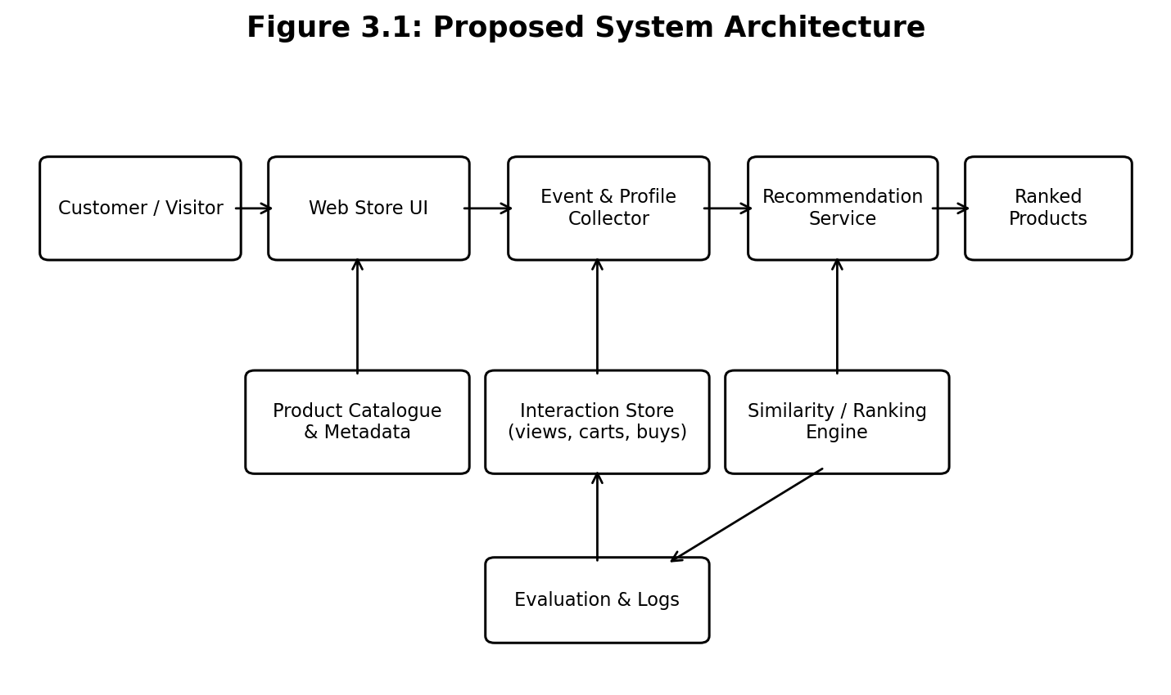
Figure 4.1: Proposed system architecture (conceptual; implementation not verified).

4.2 Architecture Layers
Layer | Responsibilities | Example data
Presentation | Display ranked items and capture clicks | Recommendation card impression
Event ingestion | Validate and record user actions | user/session, item, event, timestamp
Feature preparation | Build product vectors and user-item histories | category, text tokens, event weights
Candidate generation | Retrieve plausible products | similar items, neighbors, popular items
Ranking | Combine applicable relevance signals | content, collaborative, popularity scores
Eligibility | Remove invalid, unavailable, duplicate items | inventory and exclusion flags
Evaluation | Measure offline quality and online response | precision@K, recall@K, CTR

4.3 Data Model
A relational representation can contain User or Session, Product, Interaction, Recommendation Impression, and Recommendation Feedback entities. The model is conceptual and should be adapted to the actual persistence layer. A user profile need not store direct personal identifiers; pseudonymous keys and retention limits are preferable when feasible.
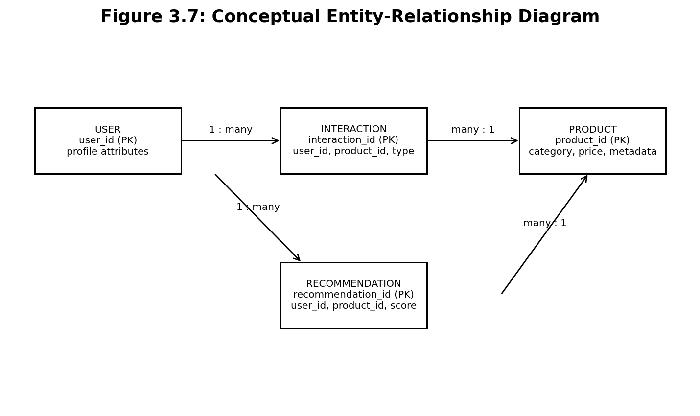
Figure 4.2: Conceptual entity-relationship diagram. Keys and relationships must be reconciled with the implemented schema.

4.4 Data Flow
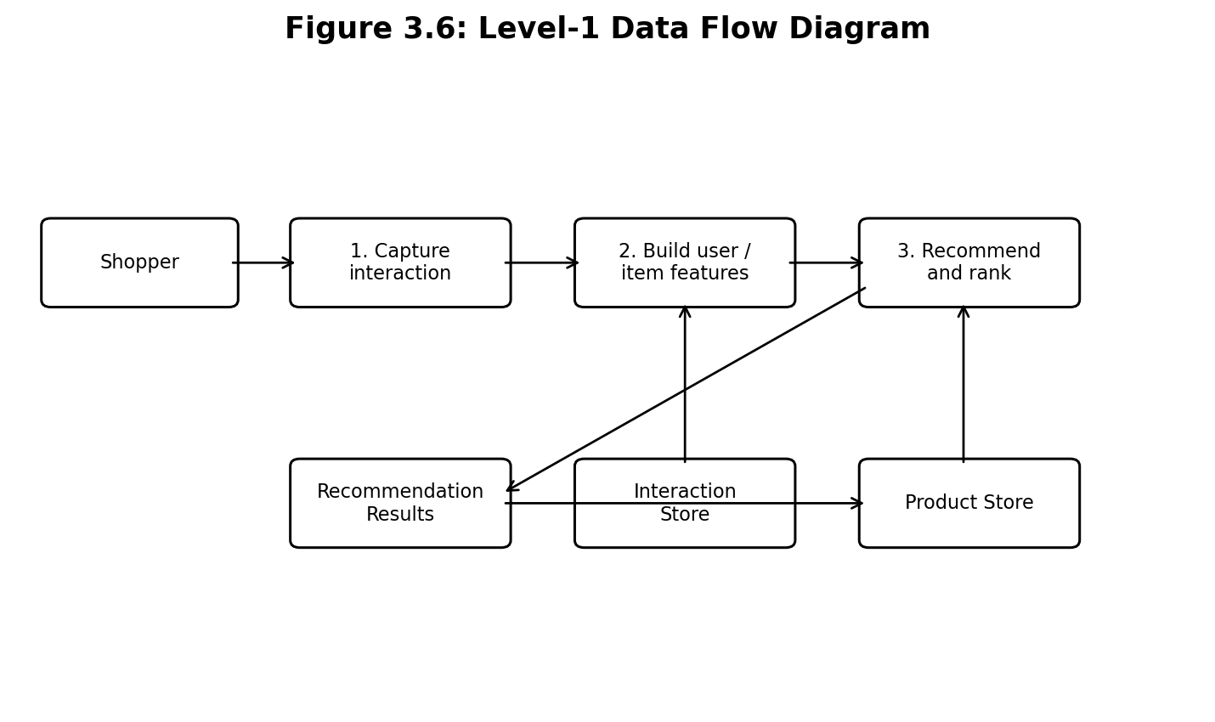
Figure 4.3: Level-1 data flow diagram for interaction capture, feature preparation, and recommendation output.

4.5 Use Case Model
The shopper browses products, receives suggestions, and may click or add a suggested product to a cart. Catalogue administrators maintain product metadata and availability. Developers or analysts inspect quality metrics and diagnose poor results. The diagram emphasizes the shopper-facing use cases; administrative capabilities are proposed and not evidence of an implemented interface.
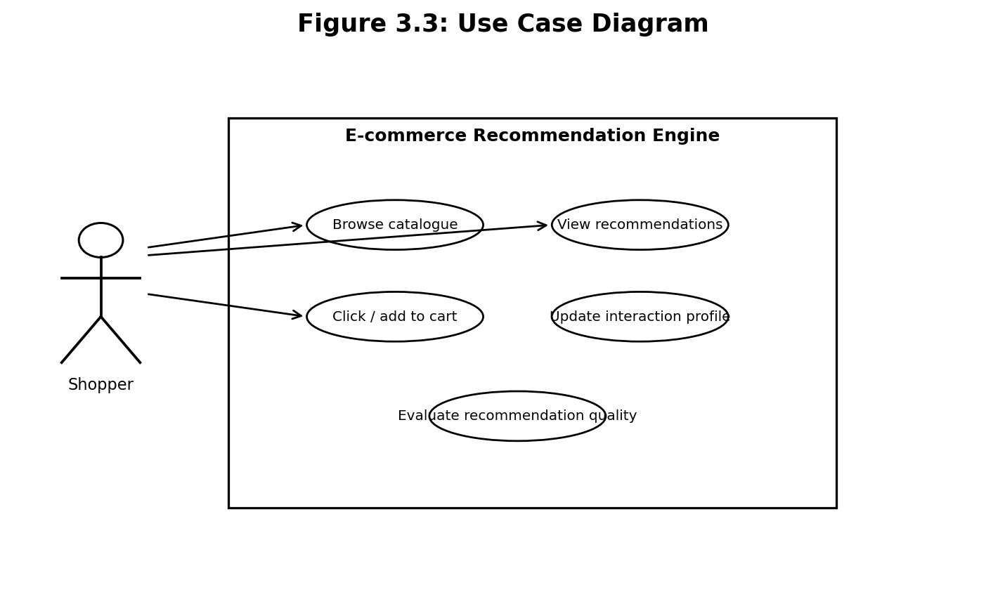
Figure 4.4: Use case diagram for the proposed engine.

4.6 Sequence of a Recommendation Request
A typical request begins when the shopper opens a product page or recommendation panel. The storefront sends the request to the recommendation API. The API obtains user or session signals, asks the ranking engine for candidates, checks product metadata and eligibility, and returns an ordered list. The storefront renders the items and logs impressions so that later clicks or conversions can be attributed carefully.
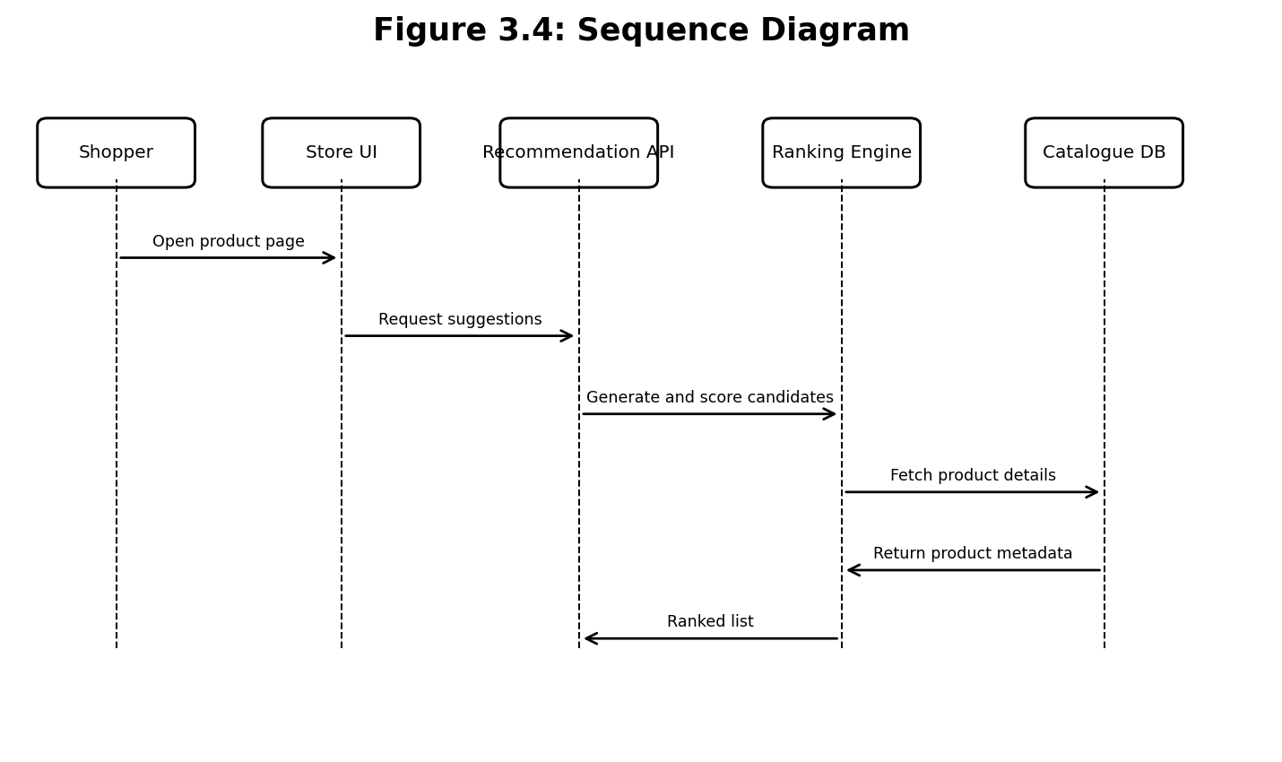
Figure 4.5: Sequence diagram for a recommendation request.

4.7 Activity Flow
The activity diagram shows a decision point for sparse history. If enough information exists, the system generates personalized candidates. Otherwise, it uses a content-based or popularity fallback. Both paths converge at filtering and ranking, after which recommendations are displayed and feedback is logged.
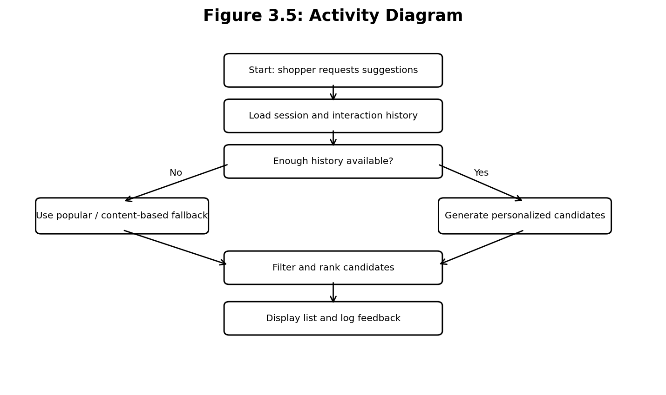
Figure 4.6: Activity diagram including a cold-start fallback.

4.8 Security and Privacy Design
- Collect only the events required for recommendation and evaluation.
- Use access controls for interaction records and administrative functions.
- Avoid returning private user history in product recommendation responses.
- Define data-retention and deletion procedures appropriate to the application.
- Validate request parameters and apply rate limits to expensive operations.
- Treat recommendation explanations as informational, not as proof of a user's private traits.

5 METHODOLOGY AND ALGORITHMS

5.1 End-to-End Methodology
The proposed workflow consists of catalogue preparation, event collection, data validation, feature extraction, candidate generation, relevance scoring, eligibility filtering, ranking, presentation, and feedback evaluation. Each stage has a clear input and output so that defects can be isolated. A baseline should be built first and measured before adding more complex methods.

5.2 Catalogue Preprocessing
Product records should be checked for missing identifiers, duplicate IDs, invalid prices, inconsistent categories, empty descriptions, and unavailable inventory. Text fields can be normalized by lowercasing, tokenization, and removal of non-informative terms when appropriate. Categorical attributes can be encoded using one-hot or multi-hot vectors. Price and numerical features should be scaled consistently.

5.3 Interaction Weighting
A simple event-weighting policy can assign different weights to views, cart additions, and purchases. For example, a project might test weights of 1, 3, and 5 respectively; these values are illustrative hyperparameters, not universal truths. Time decay can reduce the influence of old actions: w(t)=w0 exp(-λΔt), where Δt is elapsed time and λ controls decay. Both the event weights and decay rate require validation.

5.4 Content-Based Candidate Generation
A user profile can be formed by combining feature vectors of products with which the shopper interacted. A weighted profile is p_u = Σ_i w_ui x_i, where x_i is the feature vector of item i and w_ui is the interaction weight. Candidate products are scored using cosine similarity between p_u and each candidate vector. Products already viewed or purchased can be filtered according to the product policy.

5.5 Collaborative Candidate Generation
Create an interaction matrix R in which each row represents a user or session and each column represents a product. Entries can represent ratings or weighted implicit interactions. A neighborhood method computes similarity between users or items and estimates preference from neighboring interactions. For sparse or anonymous users, the collaborative score may be unavailable; the hybrid logic must not treat missing evidence as a genuine zero preference without considering the semantics.

5.6 Hybrid Scoring
For each candidate item, calculate a normalized score from the components available for that request. A weighted score is S(u,i)=αC(u,i)+βF(u,i)+γP(i)+δX(u,i). In a cold-start request, α and γ may receive greater weight; when a rich interaction history exists, β may be more informative. Weight selection should be performed using a validation set and must avoid tuning on the final test set.

5.7 Ranking and Diversity
Sort eligible candidates by descending score, with deterministic tie-breaking such as product ID. Pure relevance ranking can yield many nearly identical products. A diversity adjustment can penalize excessive similarity to already selected items or enforce category coverage. Such constraints should be evaluated because excessive diversity can reduce immediate relevance.

5.8 Complexity Considerations
A full user-item similarity computation can be expensive for large matrices. Content similarity against all products is proportional to the number of products times the feature-vector comparison cost. Candidate generation, inverted indexes, approximate nearest-neighbor retrieval, and cached popular lists can reduce online work. The actual complexity depends on representation, indexing, candidate count, and storage design.

5.9 Workflow and Pseudocode
The pseudocode below is a design outline, not source code extracted from a repository. It defines a deterministic baseline that can be implemented and unit-tested.
Figure 5.1: Recommendation workflow from signals to feedback.
Algorithm 1: Hybrid recommendation (design pseudocode)
INPUT: request context q, product catalogue I, interaction history H
1. Validate q and load eligible products from I
2. Build or retrieve the user/session feature profile
3. Generate candidates from content, collaborative, and popularity sources
4. For each candidate i:
compute available normalized component scores
combine applicable components using configured weights
5. Remove unavailable, excluded, and duplicate candidates
6. Apply optional diversity and business constraints
7. Sort by score descending with deterministic tie-breaking
8. Return top-K items and record impression metadata
OUTPUT: ranked list of eligible products

5.10 Evaluation Metrics
Metric | Definition / purpose | Caution
Precision@K | Relevant items among top K divided by K | Needs a defensible relevance label
Recall@K | Relevant held-out items retrieved in top K divided by all held-out relevant items | Depends on test split and known positives
NDCG@K | Discounted gain normalized by ideal ranking | Requires graded or binary relevance labels
Coverage | Fraction of catalogue items ever recommended | High coverage alone does not imply relevance
Diversity | Difference among items in a recommendation list | May trade off against narrow user intent
CTR | Recommendation clicks divided by impressions | Sensitive to placement and exposure bias
Conversion rate | Purchases attributed to recommendations divided by defined eligible sessions or clicks | Attribution and experiment design matter
Latency | Time to return a recommendation response | Report percentiles and test conditions

6 IMPLEMENTATION AND MODULE DESCRIPTIONS
No source-code files were supplied. This chapter therefore specifies a modular implementation plan rather than claiming that the modules already exist. Replace proposed module names and technologies with the actual repository details before submission.
Module | Responsibilities | Key validation
catalogue_loader | Load product records and validate schema | Missing IDs, duplicates, invalid attributes
event_collector | Capture views, cart events, purchases, and timestamps | Event types, time ordering, idempotency
preprocessor | Normalize text and transform categorical features | Empty profiles and malformed records
content_ranker | Compute product-feature similarity | Zero vectors and unseen categories
collaborative_ranker | Estimate scores from interaction patterns | Sparse matrices and new users/items
hybrid_ranker | Combine scores and fallback policies | Weight normalization and missing components
eligibility_filter | Remove unavailable or excluded items | Stale inventory and duplicate candidates
recommendation_api | Expose request/response contract | Schema validation, timeout, error handling
evaluation_pipeline | Compute offline metrics and comparison tables | Data leakage and reproducibility
monitoring | Record latency, failures, impressions, and clicks | Privacy, sampling, and retention

6.1 Suggested API Contract
A recommendation request may contain a pseudonymous user or session identifier, optional current product ID, a requested list size K, and context such as device or category when permitted. A response may contain product IDs, ranking scores, and concise reason codes. The API should not return raw interaction history. Error responses should distinguish invalid input, unavailable catalogue data, and temporary service failure.

6.2 Example Request and Response (Illustrative)
Request: { "session_id": "demo-session", "product_id": "P100", "k": 5 }
Response: { "items": [{"product_id":"P203","score":0.82,"reason":"similar_category"}] }
The identifiers and scores above are synthetic examples used only to explain the interface. They are not extracted from an implementation or experimental run.

6.3 Error Handling
- If the requested product does not exist, return a controlled validation response or use a documented fallback.
- If no user history exists, use content-based or popularity recommendations.
- If a ranking component times out, return a safe fallback only if the system can verify eligibility.
- If the catalogue is empty, return an empty list and a diagnostic event rather than fabricated products.
- Log operational failures without writing unnecessary personal data to logs.

6.4 Reproducibility
Every evaluation should record the dataset version, train-validation-test split, time window, feature definitions, model configuration, random seed where applicable, software version, hardware, and metric implementation. Offline splits should respect time when the intended deployment predicts future actions; random splits can leak future behavior into training. A report should include only results that can be reproduced from retained artifacts.

7 EXPERIMENTAL RESULTS, TESTING AND DISCUSSION

7.1 Evidence Available
The two supplied PDFs do not contain the e-commerce project’s source code, data files, test logs, runtime measurements, or actual recommendation outputs. The eight-page overview provides qualitative examples: viewed items, cart additions, past purchases and searches as signals; content-based and collaborative recommendation as two approaches; and product discovery, personalization, and product connections as expected benefits. These statements support the design rationale but do not establish measured performance.

7.2 Experimental Plan
A valid experiment should use a versioned interaction dataset, define a chronological or otherwise justified holdout, train or configure each recommender only on the training portion, and evaluate ranked results on held-out interactions. Compare at least a popularity baseline, content-based approach, collaborative approach when enough data exists, and hybrid approach. Use the same split and eligibility rules for each method. Record cold-start performance separately from warm-user performance.

7.3 Illustrative Score Chart
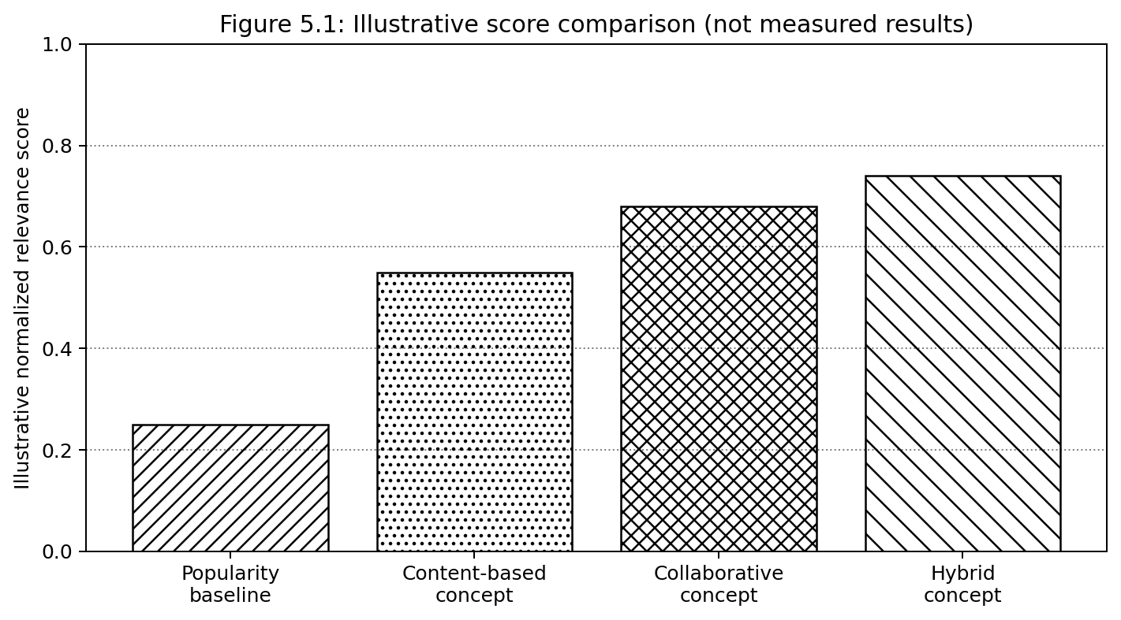
Figure 7.1: Illustrative normalized scores only. These values are fabricated for visualization and are not experimental findings.
The graph demonstrates how results could be presented; it must not be cited as evidence that hybrid recommendation outperforms the alternatives. Actual values should be calculated from the project dataset and evaluation pipeline.

7.4 Illustrative Test Cases
Test ID | Scenario | Expected behavior | Status
T01 | Valid product catalogue | Records load and IDs are unique | Proposed test; not executed
T02 | Unknown product ID | Controlled error or defined fallback | Proposed test; not executed
T03 | New shopper with no history | Fallback returns eligible items | Proposed test; not executed
T04 | Product out of stock | Item is excluded from final list | Proposed test; not executed
T05 | Duplicate interaction event | Idempotency policy is followed | Proposed test; not executed
T06 | Equal candidate scores | Stable tie-break order | Proposed test; not executed
T07 | Empty catalogue | Empty result and diagnostic response | Proposed test; not executed
T08 | Ranking component unavailable | Safe fallback or controlled failure | Proposed test; not executed
T09 | Privacy access check | Unauthorized history access is denied | Proposed test; not executed
T10 | Evaluation repeatability | Same configuration yields same metrics | Proposed test; not executed

7.5 Performance Analysis Method
Measurement | How to collect | Report format
Response latency | Run repeated requests under documented load | Median, p95, p99 in milliseconds
Throughput | Increase concurrent requests in controlled steps | Successful requests per second
Offline relevance | Compute Precision@K, Recall@K, NDCG@K | Per model and segment
Catalogue coverage | Count unique recommended items / eligible catalogue | Percentage
Cold-start quality | Evaluate users/items with no prior training history | Separate metric table
Resource use | Capture CPU and memory during tests | Peak and average with machine details

7.6 Results Interpretation
When actual measurements are available, interpretation should distinguish relevance, coverage, latency, and operational reliability. A model may improve NDCG while reducing catalogue coverage, or improve click-through rate while concentrating exposure on a small set of popular products. Results should be reported by user-history segment and product category where sample sizes permit. Confidence intervals or repeated trials can help determine whether observed differences are stable.

7.7 Discussion
The design reflects the conceptual framework in the supplied e-commerce overview: recommendations begin with shopper signals, identify connections, rank candidates, and present a short list. Content-based and collaborative methods provide complementary evidence. However, a recommendation engine’s real value cannot be established from diagrams alone. Data quality, event instrumentation, evaluation design, and user-interface placement all affect observed outcomes. Consequently, no numerical improvement in sales, click-through rate, or conversion is claimed in this report.

8 CONCLUSION, LIMITATIONS AND FUTURE ENHANCEMENTS

8.1 Conclusion
This report develops a structured design for an e-commerce recommendation engine intended to help shoppers discover relevant products in a large online catalogue. It defines a pipeline for capturing behavior, preparing features, generating candidates, combining recommendation signals, filtering ineligible products, ranking the remaining items, and recording feedback. The content-based, collaborative, popularity-based, and hybrid approaches are described as complementary design options rather than interchangeable solutions.
The proposed architecture separates presentation, event ingestion, feature processing, ranking, eligibility filtering, and evaluation. This separation supports testing and future replacement of individual components. The report also defines requirements, conceptual data entities, API examples, algorithms, diagrams, and a testing plan. The diagrams and sample API values are explanatory artifacts; they do not verify that a corresponding application has been built.
The most important next step is to connect this design to the actual project materials. The source code should be inspected, the real data schema documented, tests executed, and evaluation results calculated from a reproducible dataset. Until that evidence exists, performance figures and implementation claims must remain explicitly unverified.

8.2 Limitations
- The reference CSV requested for citations was not supplied, so a bibliography derived exclusively from that CSV cannot be produced.
- No source-code repository or existing editable report was provided; implementation details are proposed rather than verified.
- No real dataset, test log, benchmark, or deployed-service measurement was supplied.
- The illustrative graph uses fabricated values for layout demonstration and must not be presented as measured results.
- The conceptual ER diagram and API example must be aligned with the final schema and interface.
- The report uses the available overview PDF for the project's conceptual framing but cannot verify commercial or scientific claims beyond that source.

8.3 Future Enhancements
- Integrate the actual catalogue and interaction dataset with data validation and privacy controls.
- Implement a baseline content-based recommender and compare it with popularity-based ranking.
- Add collaborative filtering after enough interactions have accumulated.
- Tune hybrid weights on a validation set and evaluate on a separate chronological test set.
- Use ranking diversity and coverage metrics alongside relevance metrics.
- Introduce real-time inventory checks, caching, and asynchronous event processing if needed.
- Add explanations such as “similar category” or “frequently viewed together” only when supported by the actual scoring logic.
- Monitor drift, cold-start behavior, popularity concentration, latency, and error rates.
- Conduct an appropriately designed online experiment before claiming business impact.
- Complete references from the approved CSV and update all captions, page numbers, and implementation descriptions after final validation.

8.4 Final Recommendation
Before academic submission, replace the guide placeholder, confirm the official departmental cover-page template, add the reference CSV-derived bibliography and citations, and reconcile each implementation and result statement with the actual code and experimental artifacts. This draft is formatted as a full project-report framework, but the evidence gaps must be resolved for it to be treated as a final verified project report.

REFERENCES
1. R. A. and co-authors, “A Systematic Study on the Recommender Systems in the E-Commerce,” IEEE Access, vol. 8, pp. 115694–115716, 2020. https://doi.org/10.1109/ACCESS.2020.3002803.
2. A. Da’u and N. Salim, “Recommendation System Based on Deep Learning Methods: A Systematic Review and New Directions,” Artificial Intelligence Review, vol. 53, pp. 2709–2748, 2020. https://doi.org/10.1007/s10462-019-09744-1.
3. “Recommender Systems Leveraging Multimedia Content,” ACM Computing Surveys, vol. 53, no. 5, 2020/2021. https://doi.org/10.1145/3426973.
4. N. AlRossais, D. Kudenko, and T. Yuan, “Improving Cold-Start Recommendations Using Item-Based Stereotypes,” User Modeling and User-Adapted Interaction, vol. 31, pp. 867–905, 2021. https://doi.org/10.1007/s11257-021-09293-9.
5. C. Bernardis and P. Cremonesi, “NFC: A Deep and Hybrid Item-Based Model for Item Cold-Start Recommendation,” User Modeling and User-Adapted Interaction, vol. 32, pp. 747–780, 2022. https://doi.org/10.1007/s11257-021-09303-w.
6. “A Survey of Learning-Based Methods for Cold-Start, Social Recommendation, and Data Sparsity in E-commerce Recommendation Systems,” in Proceedings of the 16th International Conference on Intelligent Systems and Knowledge Engineering (ISKE), 2021. https://doi.org/10.1109/ISKE54062.2021.9755389.
7. “E-Commerce Recommendation Technology Based on Collaborative Filtering Algorithm and Mobile Cloud Computing,” Wireless Communications and Mobile Computing, 2022. https://doi.org/10.1155/2022/7321021.
8. L. Liu, “e-Commerce Personalized Recommendation Based on Machine Learning Technology,” Mobile Information Systems, 2022. https://doi.org/10.1155/2022/1761579.
9. “A Survey and Comparative Analysis of Relevant Approaches of Recommendation System,” IEEE conference publication, 2023. https://doi.org/10.1109/IC3I59117.2023.10397781.

10. “Testing the Performance of Online Recommendation Agents: A Meta-Analysis,” Journal of Retailing, vol. 99, no. 3, pp. 440–459, 2023. https://doi.org/10.1016/j.jretai.2023.08.001.

11. “Application of Recommended Systems for E-commerce,” Procedia Computer Science, vol. 231, pp. 329–334, 2024. https://doi.org/10.1016/j.procs.2023.12.212.
12. “A Personalized Product Recommendation Model in E-commerce Based on Retrieval Strategy,” Journal of Open Innovation: Technology, Market, and Complexity, vol. 10, no. 2, article 100303, 2024. https://doi.org/10.1016/j.joitmc.2024.100303.
13. “E-commerce Recommender System Based on Improved K-means Commodity Information Management Model,” Heliyon, vol. 10, no. 9, article e29045, 2024. https://doi.org/10.1016/j.heliyon.2024.e29045.
14. A. Valencia-Arias et al., “Artificial Intelligence and Recommender Systems in E-commerce: Trends and Research Agenda,” Intelligent Systems with Applications, vol. 24, article 200435, 2024. https://doi.org/10.1016/j.iswa.2024.200435.
15. C. S. Rajpoot, V. Tiwari, and S. K. Vishwakarma, “Emerging Trends of Recommender System for E-commerce: A Comprehensive Review,” Discover Computing, vol. 29, article 63, 2026. https://doi.org/10.1007/s10791-026-09923-z.

